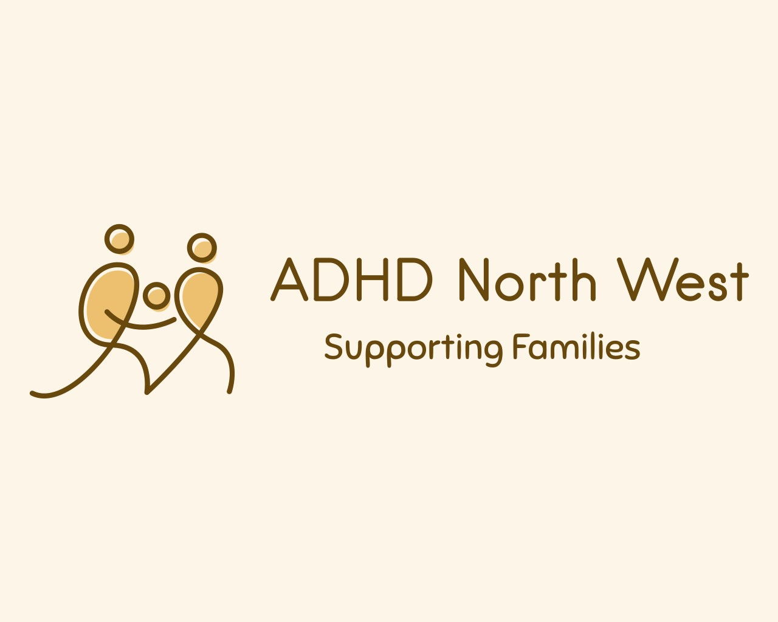
Patient safety incident response plan
Effective date: 7th August 25
Estimated refresh date: September 2026
 | NAME | TITLE | SIGNATURE | DATE
Author | Carolyn Litherland | Operational  Manager |  | 7.8.25
Reviewer
Authoriser

Contents
Introduction 3
Our services 4
Defining our patient safety incident profile 5
Defining our patient safety improvement profile 6
Our patient safety incident response plan: national requirements 7
Our patient safety incident response plan: local focus 8

Introduction
ADHD North West's approach to patient safety incident response is flexible and adaptable. The 12–18-month plan is not a rigid set of rules but rather a framework that can be adjusted to accommodate the specific circumstances of each incident and the needs of those affected. This flexibility demonstrates a commitment to a patient-centred approach and continuous improvement.

Our services
ADHD North West are commissioned by Lancashire and South Cumbria Integrated Care Board to provide ADHD support for families who are registered with a GP in Lancashire and South Cumbria. Clients can be referred into our service via GP’s, Paediatricians, CAMHS and schools, or parents can make a self-referral.

ADHD North West is committed to providing a unique support service to empower and improve the wellbeing of individuals and families affected by an Attention Deficit Hyperactivity Disorder and associated conditions. We believe in making a difference by improving knowledge, and mental health, increasing confidence, reducing isolation, and encouraging aspirations.

Our services include: -

Telephone helpline

Outreach support

ADHD focused parenting course

Advocacy
  - consultations

Multiagency meetings

Support groups

Defining our patient safety incident profile
ADHD Northwest is dedicated to ongoing learning from patient safety events, which encompass incidents such as suicide, self-harm, harm to others, and concerns involving at-risk children. While stakeholder involvement was absent, discussions were held with the board, and consultations with the ICB patient safety team took place to grasp the PSIRF requirements and the practical aspects of planning and implementation.

In order to establish our patient safety response profile, we have analysed incidents for recurring themes and trends while also considering feedback from clients and service users, as well as complaints. We have examined the data for insights into disparities in patient safety and are prepared to assist larger organisations with investigations into patient safety incidents and the Integrated Care Board when needed, particularly when opportunities for learning and improvement arise.

Defining our patient safety improvement profile
ADHD North West is dedicated to gaining insights from patient safety incidents. Once an area for improvement is recognised, plans will be developed to outline specific actions, which will then be communicated to the staff.

Our patient safety incident response plan: national requirements
Certain patient safety incidents, including Never Events and fatalities believed to be primarily linked to care deficiencies, necessitate a Patient Safety Incident Investigation (PSII) for the purpose of learning and enhancement. At ADHD North West, the number of reported incidents is currently zero, and we have not yet reached the national threshold for conducting investigations. Nevertheless, we will maintain a flexible approach and evaluate improvement strategies as needed if any risks or patient safety concerns arise from our internal assessments or external information.

Patient safety incident type | Required response | Anticipated improvement route
Incidents meeting the Never Events criteria | PSII | Would support larger organisation to develop local organisational actions
E.G  Death thought more likely than not due to problems in care (incident meeting the learning from deaths criteria for patient safety incident investigations (PSIIs)) | PSII | Would support larger organisation to develop local organisational actions
Mental health-related homicides | Referred to the NHS England Regional Independent Investigation Team  (RIIT) for consideration for an independent PSII  Locally-led PSII may be required | As decided by the RIIT
Deaths of persons with learning disabilities | Refer for Learning Disability Mortality Review (LeDeR)  Locally-led PSII (or other response) may be required alongside the  LeDeR – organisations should liaise with this | LeDeR programme
Domestic homicide | A domestic homicide is identified by the police usually in partnership  with the community safety partnership (CSP) with whom the overall responsibility lies for establishing a review of the case where the CSP considers that the criteria for a domestic homicide review (DHR) are met, it uses local contacts and requests the establishment of a DHR panel.  The Domestic Violence, Crime and Victims Act 2004 sets out the statutory obligations and requirements of organisations and commissioners of health services in relation to DHR | CSP

Our patient safety incident response plan: local focus

PSIRF allows organisations to explore patient safety incidents relevant to their context and the populations served. We have identified the client safety priorities set out below:

Client safety incident type or issue | Planned response | Anticipated improvement route
Safeguarding Children | Action Review (AAR)  Follow our Safeguarding Children Policy.  Refer to Multi-Agency Safeguarding Hub | Recognise key opportunities for growth and education. Create local safety actions
Documentation/IG Breach | Action Review (AAR)  Follow our Data Security policy, refer to the IG handbook  Facilitated staff discussion following an event or activity | Recognise key opportunities for growth and education. Create local safety actions

All incidents will be reported through LFPSE regardless of level of investigation required.

